Restorative Rest
Tuesday 9th August 2022
10.30am – 12.30pm, Fellwood Training Room, Wigton Hospital
& Tuesday 16th August 2022
10.30am – 12.30pm, Learning Suite, Wigton Hospital

Is lack of sleep affecting your daily life? This two-part workshop looks at the following:

- Why do we need sleep?  - How many hours of sleep do we need to function well? | - Problems and barriers to a good night’s rest
- What have you already tried? | - Keeping a Sleep diary
- Goal setting and strategies for change | - Mindfulness and relaxation techniques

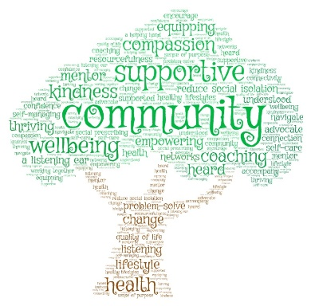
To book please contact;

Hazel Stewart : 07917 265 287

Book your ticket
at: https://www.eventbrite.co.uk/e/387399942657

Or email : wellbeing@NCIC.nhs.uk

